

AI-Powered Health Assistant

A Project Report

submitted in partial fulfillment of the requirements of

AICTE Internship on AI: Transformative Learning with

TechSaksham – A joint CSR initiative of Microsoft & SAP

by

## MD SHUFYAIN SHAHEJER, mdshufyainshahejer02@gmail.com

Under the Guidance of

# JAY RATHOD

**P. ADARSH**



### ACKNOWLEDGEMENT

I would like to express my sincere gratitude to **Mr. Jay Rathod** and **Mr. P. Adarsh** for their invaluable guidance, support, and mentorship throughout the development of my project,

**“AI-Powered Health Assistant”**. Their insights and encouragement played a crucial role in shaping this project.

I also extend my heartfelt appreciation to the **TechSaksham** Initiative by **Microsoft** and **SAP** for providing me with this incredible internship opportunity. This experience has been instrumental in enhancing my knowledge of artificial intelligence, machine learning, and healthcare technology. Through this project, I have gained hands-on experience in natural language processing (NLP), chatbot development, data analysis, and model optimization, which have significantly strengthened my technical skills. Additionally, I have developed a deeper understanding of real-world problem- solving, teamwork, and project management.

Lastly, I am grateful to my peers, mentors, and everyone who contributed to my learning journey, directly or indirectly.

Thank you!

Vineet Kumar Chaturvedi.



**ABSTRACT**

With the rapid advancement of artificial intelligence (AI) and natural language processing (NLP), AI-powered chatbots have gained significant importance in the healthcare sector. This project presents an AI-Powered Health Assistant Chatbot designed to provide users with basic health-related information, symptom analysis, and preliminary medical guidance. The chatbot is implemented using the Hugging Face Transformer library, utilizing the DistilGPT-2 model through the pipeline text-generation function. The chatbot can assist users by responding to health-related queries, offering symptom-based suggestions, and directing them to appropriate healthcare resources.

### TABLE OF CONTENT

**Abstract** **I**

**Chapter 1I.ntroduction** **1-3**

1.1

1.2

1.3

1.4.

Problem Statement 1

Motivation 1

Objectives. 2

Scope of the Project 2-3

**Chapter 2Literature Survey** **4-5**

**.**

* 1. Review of Relevant Literature 4
  2. Existing Models and Techniques 5
     1. Rule-Based Chatbots… 5
     2. Machine Learning-Based Chatbots… 5
     3. Transformer-Based AI Chatbots (Deep Learning Models) 5
  3. ​

**Chapter 3.**

3.1

3.2

Gaps and Limitations in Existing Solutions… 5

**Proposed Methodology** **6-8**

System Design… 6-7

Workflow Diagram… 8

* + 1. Hardware Specification… 8
    2. Software Requirement… 8

Chapter 4. Implementation and Results… 9-11



* 1. Snap Shots and Result… 9-10
  2. GitHub Link for code… 11

Chapter 5. Discussion and Conclusion… 11-13

* 1. Discussion… 11
  2. Future Work… 11-12
  3. Conclusion… 12-13

References 13

### LIST OF FIGURES

|  |  |  |
| --- | --- | --- |
| **Figure No.** | **Figure Caption** | **Page No.** |
| **Figure 1** | NLP + AI Chatbots | **3** |
| **Figure 2** | Chatbot Architecture AI Chatbot | **4** |
| **Figure 3** | Limitations in Healthcare How an AI | **5** |

**Figure 4**



**Figure 5**

**Figure 6**

**Figure 7**

**Figure 8**

Chatbot Works Health Chatbot **6**

Flowchart Main Interface User **7**

Query of appointment Processing **9**

user query **10**

**10**

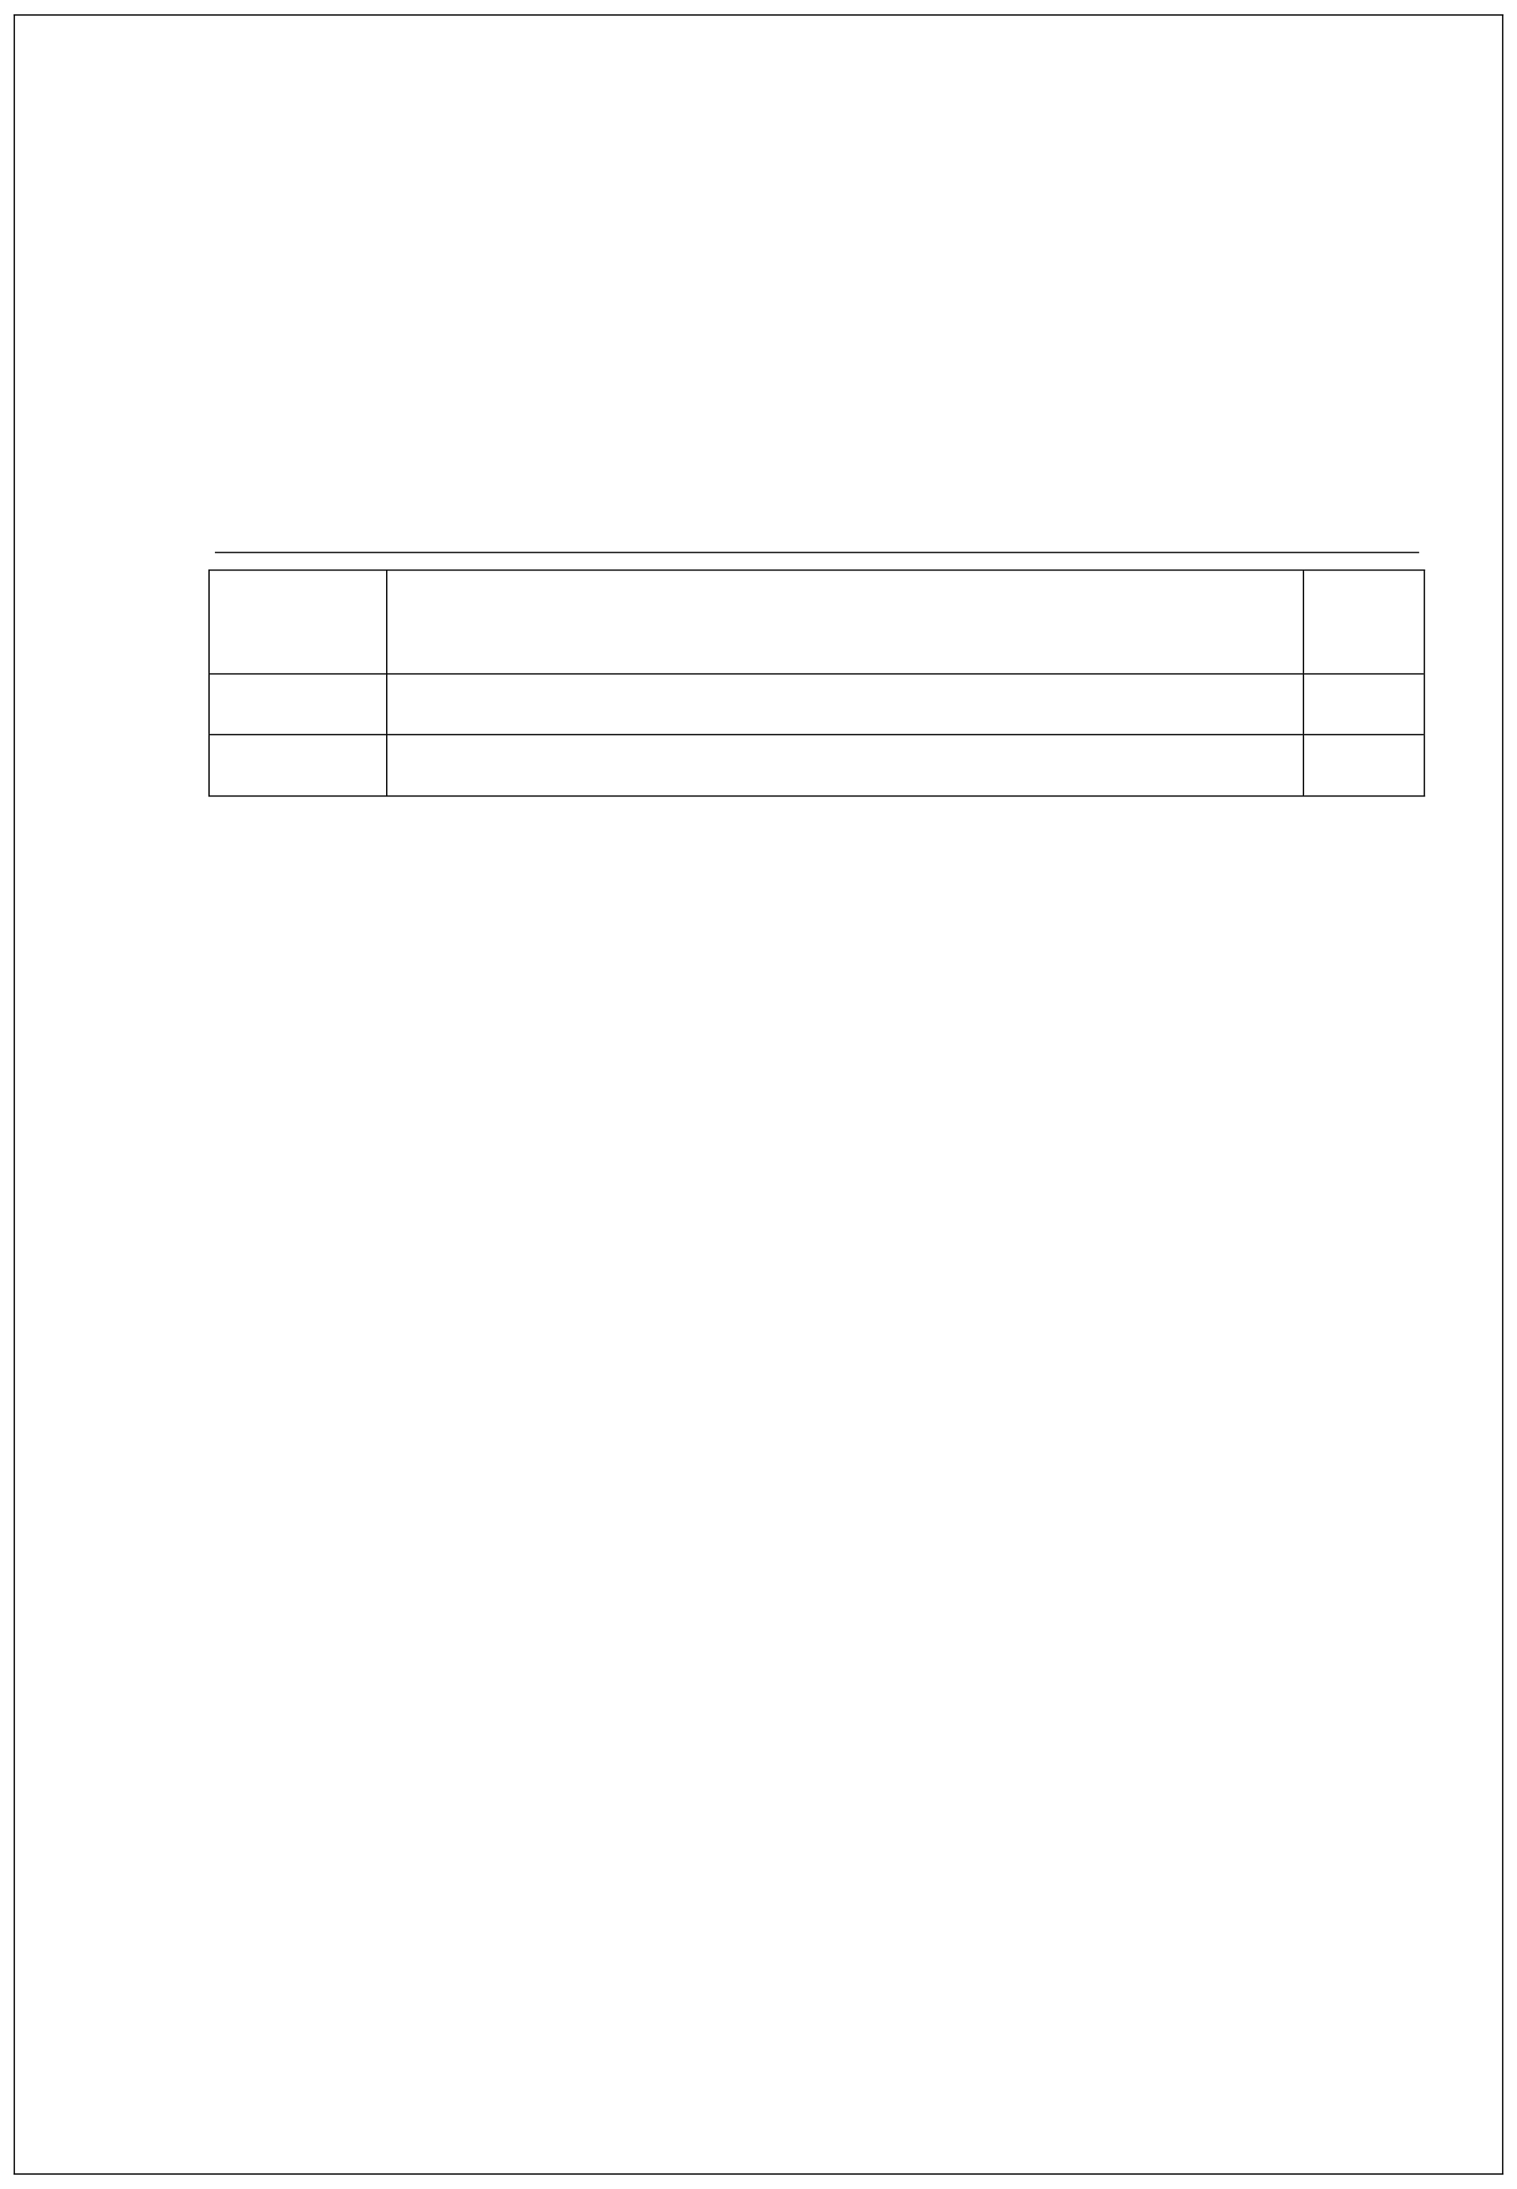

**Table. No.**

**1.**

**2.**

### LIST OF TABLES

**Table Caption**

Hardware Requirement Software Requirement

**Page No.**

**8**

**8**

# CHAPTER 1

## Introduction

#### Problem Statement:

In today’s fast-paced world, accessing reliable healthcare information quickly and efficiently is a significant challenge. Many individuals turn to the internet for symptom analysis and medical advice, but the information found online is often unverified, misleading, or difficult to interpret. Additionally, the increasing burden on healthcare professionals makes it difficult for them to provide instant consultations for every minor health concern. To address this issue, an AI-powered health assistant chatbot can act as a first point of contact for users seeking basic medical guidance. By leveraging natural language processing (NLP) and machine learning, the chatbot can analyze user queries and provide relevant health-

rseelravtesd arsesaponses. While it does not replace professional medical diagnosis, it preliminary support system to help users make informed decisions about their health.

#### Motivation:

The motivation behind this project arises from several key factors:

* + - Growing demand for AI in healthcare: AI-driven solutions are revolutionizing

various industries, including healthcare, by providing quick and accessible

information.

* Limited availability of instant medical consultation: Many individuals hesitate to visit a doctor for minor symptoms, leading to delayed treatment.
* Accessibility of healthcare information: A chatbot can bridge the gap between users and medical resources, offering basic health advice in real time.
* Reduction of misinformation: Online health forums and unreliable sources often spread incorrect medical advice. A trained AI chatbot can help provide more structured and reliable responses.
* Advancements in NLP and deep learning: With models like DistilGPT-2, AI chatbots can generate contextually relevant and human-like responses, improving user engagement.

p g . 1

#### Objective:

The main objectives of this project are:

* + - To develop an AI-powered chatbot capable of providing basic healthcare guidance using Hugging Face model.
    - To implement a text-generation pipeline using pipeline text-generation for generating health-related responses.
    - To create a user-friendly interface for easy interaction with the chatbot.
    - To ensure the chatbot provides informative and relevant responses based on general health-related queries.
    - To maintain ethical considerations such as user data privacy, AI fairness, and responsible AI deployment in healthcare applications.

#### Scope of the Project:

The AI-Powered Health Assistant Chatbot is designed to function as an informational tool rather than a diagnostic system.

In-Scope Features:

✔. Provides basic health-related information based on user queries.

✔. Suggests possible symptoms and general health advice using AI-generated text.

✔. Utilizes Hugging Face’s DistilGPT-2 model for response generation.

✔. Can be expanded with additional medical datasets to improve accuracy.

✔. Can be integrated into web or mobile platforms for accessibility.

Out-of-Scope Features:

❌. The chatbot does not provide medical diagnoses or prescriptions.

❌. It cannot replace professional medical consultation.

❌. It does not handle emergency medical conditions or critical health issues.

p g . 2



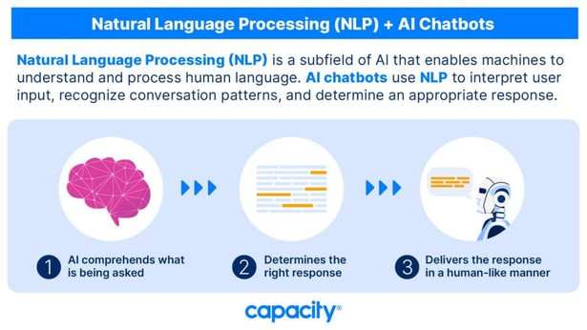

Fig1. NLP + AI Chatbots

p g . 3

# CHAPTER 2

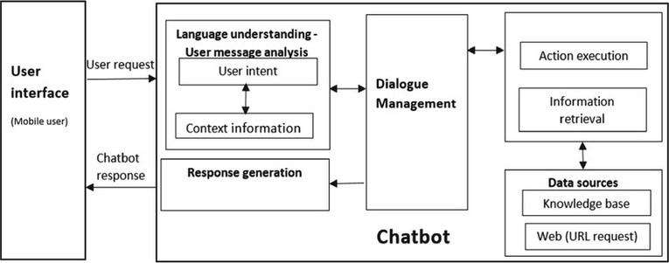

## Literature Survey

#### Review of Relevant Literature

The integration of artificial intelligence (AI) in healthcare has gained significant traction in recent years. Various studies highlight the potential of AI-powered chatbots in assisting patients, reducing the burden on healthcare professionals, and providing timely medical advice.

Key Findings from Previous Research:

* Chatbot Applications in Healthcare: Research has demonstrated that AI-powered chatbots can assist in mental health support, symptom checking, and chronic disease management.
* Natural Language Processing (NLP) for Healthcare: NLP models, such as GPT-2, BERT, and Transformer-based architectures, have been widely used to analyze and interpret medical text.
* AI Chatbots vs. Traditional Healthcare Systems: While AI chatbots provide quick responses, they lack the depth of knowledge and emotional intelligence that human doctors possess.
* These studies suggest that AI-driven chatbots can serve as preliminary assistants in healthcare by providing general medical information, symptom analysis, and first- line health advice.

Fig2: Chatbot Architecture

p g . 4

#### Existing Models and Techniques

* + 1. Rule-Based Chatbots
       - Operate on predefined responses based on if-else logic.
       - Limited in handling complex or dynamic medical conversations.
       - Example: MedWhat (basic rule-based model).
    2. Machine Learning-Based Chatbots
       - Use supervised learning techniques for intent classification and response generation.
       - Require large labeled datasets to function effectively.
       - Example: Ada Health, which uses ML algorithms to assess symptoms.
    3. Transformer-Based AI Chatbots (Deep Learning Models)
       - Utilize self-attention mechanisms for improved context understanding.
       - Can generate coherent and contextually relevant responses.
       - Example: GPT-2, BERT, and DistilGPT-2.

#### 2.2Gaps and Limitations in Existing Solutions

Despite advancements in AI-driven chatbots, there are several gaps and challenges that

need to be addressed:

Fig3: AI Chatbot Limitations in Healthcare

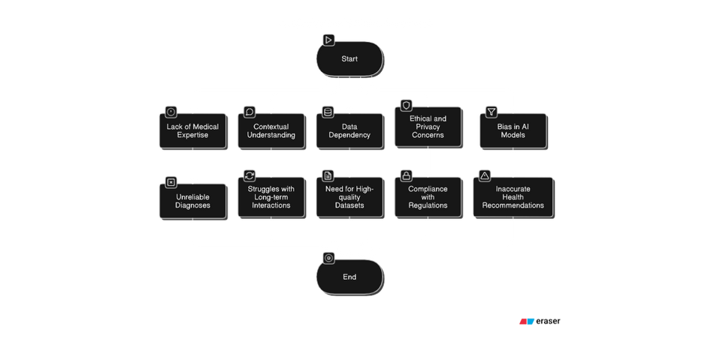

p g . 5

# CHAPTER 3

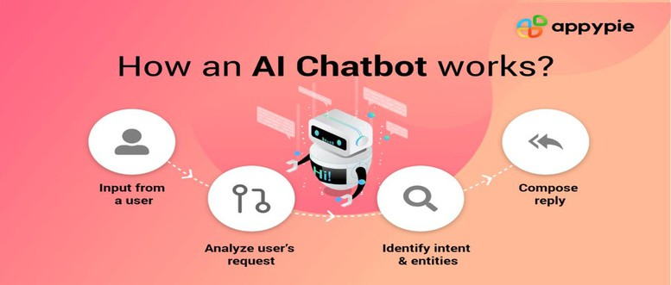

## Proposed Methodology

#### System Design

Fig4: How an AL Chatbot Works

The AI-Powered Health Assistant Chatbot is designed to provide users with instant health- related responses using natural language processing (NLP). The system architecture consists of three major components:

* + 1. System Architecture

The chatbot follows a three-layer architecture:

* + - * User Interface Layer

Web-based or mobile chatbot interface where users input their health-related queries. Simple text-based conversation format.

* + - * Processing Layer

Uses Hugging Face’s DistilGPT-2 for text generation. Processes user input, generates relevant responses, and filters inappropriate content.

p g . 6

* + - * Response Layer

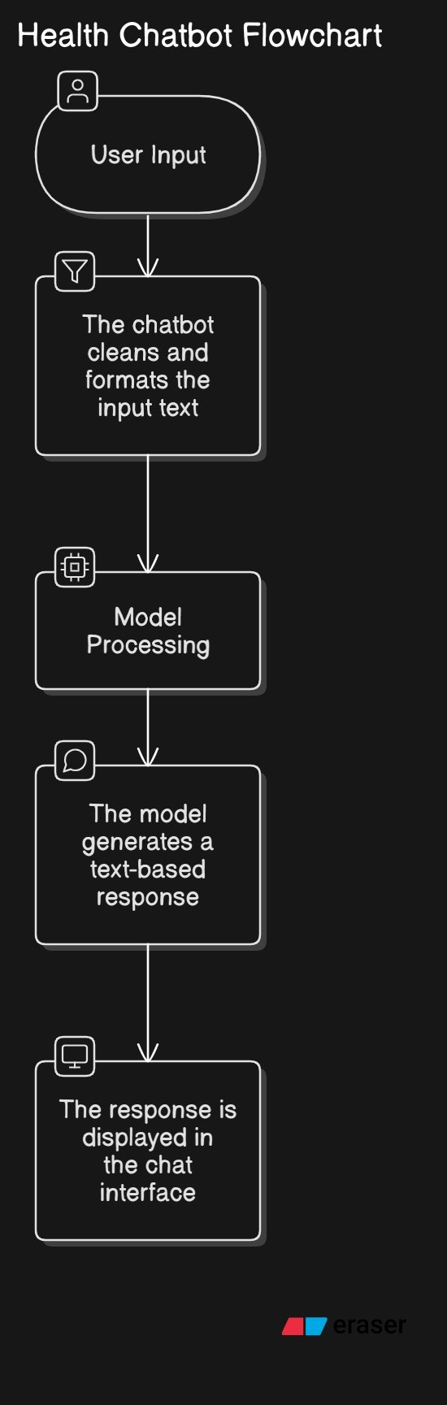

Sends the AI-generated response back to the user. Provides basic health information but does not diagnose diseases.

* + 1. Workflow Diagram

The chatbot’s workflow follows these steps:

Fig5. Health Chatbhot Flowchart

p g . 7

#### Requirement Specification

* + 1. **Hardware Requirements:**

To ensure smooth operation and model inference, the following hardware specifications are recommended:

**Component Minimum Requirement Recommended**

**Requirement**

**Processor RAM**

**GPU (Optional)**

**Storage**

Intel i5 / AMD Ryzen 5 8GB

Integrated Graphics

10GB free space

Intel i7 / AMD Ryzen 7+ 16GB+

NVIDIA GTX 1650 / RTX

3050+ (for better AI processing)

**SSD (for faster processing)**

Table1. Hardware Requirement table

* + 1. **Software Requirements:**

The chatbot development and deployment require the following software tools:

**Software Programming Language**

**AI/ML Framework Libraries**

**Deployment Platform**

**Version/Technology**

Python 3.11

Hugging Face Transformers, PyTorch Transformers, TensorFlow/PyTorch, Flask,

NumPy, Pandas

Flask (API), Streamlit (optional UI), Cloud (AWS/GCP)

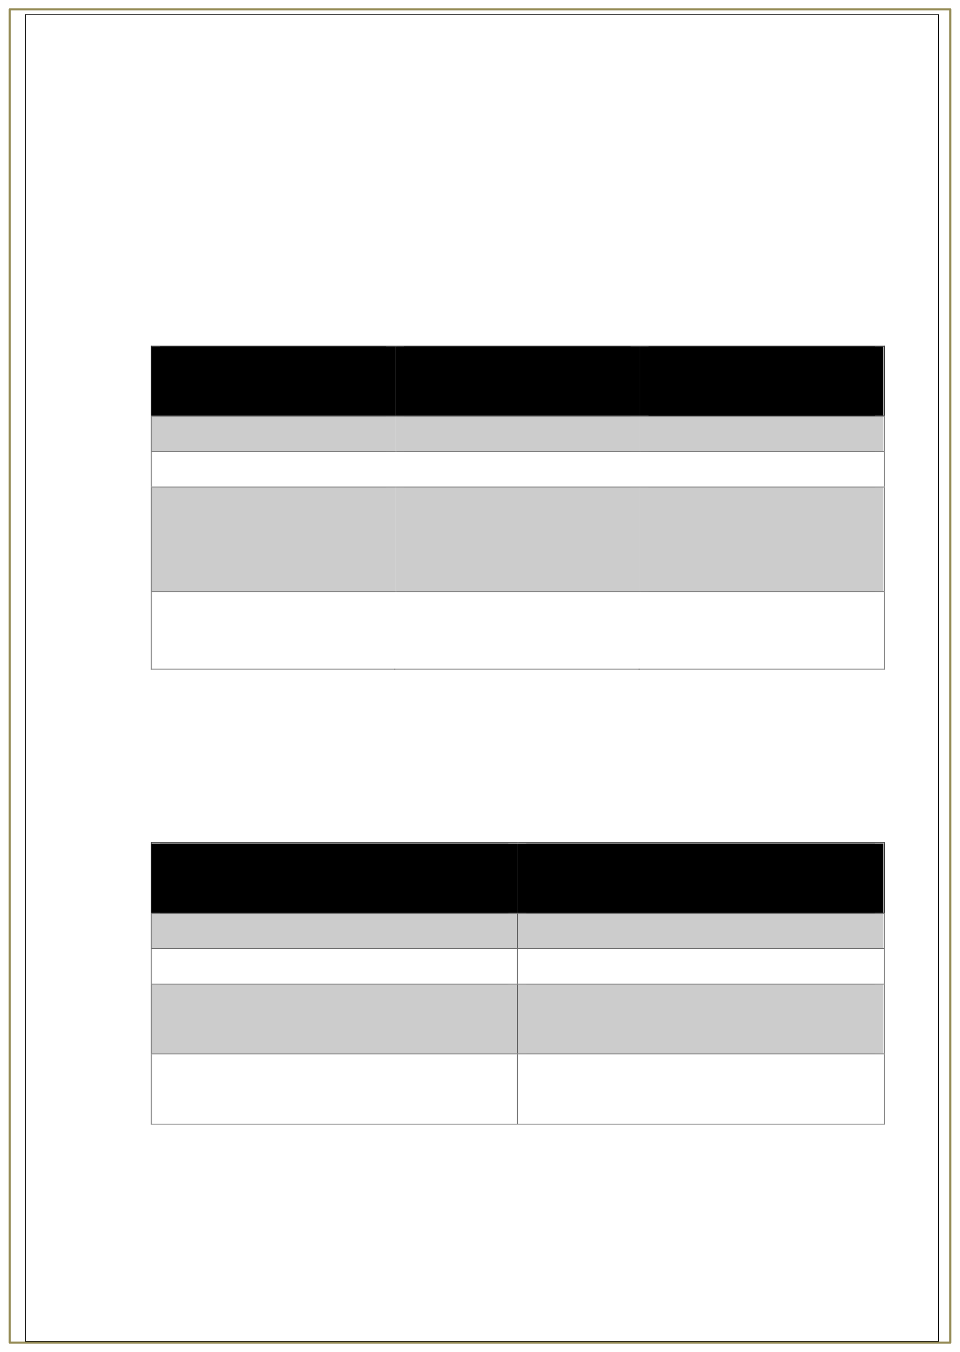

Table2. Software Requirement

p g . 8

# CHAPTER 4

## Implementation and Result

#### Snap Shots of Result:

* + - Opening of the AI Healthcare Assistant Chatbot

This screen likely shows the chatbot's welcome message or introduction. It may include options for users to interact, such as asking health-related questions or booking appointments.

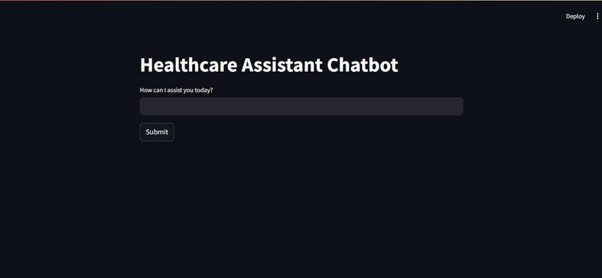

Fig6. Main Interface

* + - User Input: "Book Appointment"

The chatbot detects the intent of booking an appointment. It asks the user for confirmation.

p g . 9



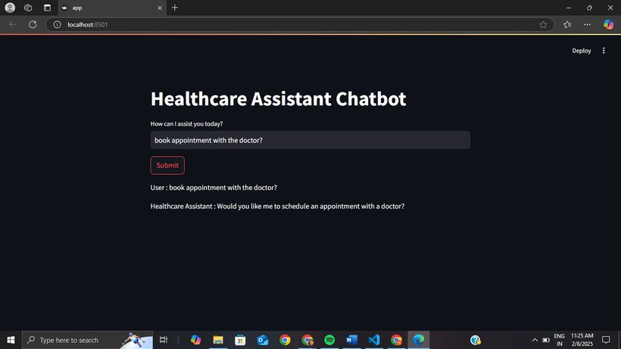

Fig7. User Query of appointment

* + - User Query: "I have a headache and fever. What could be the reason?"

The chatbot processes the symptoms provided by the user. It might give possible causes, suggest home remedies, or recommend consulting a doctor.

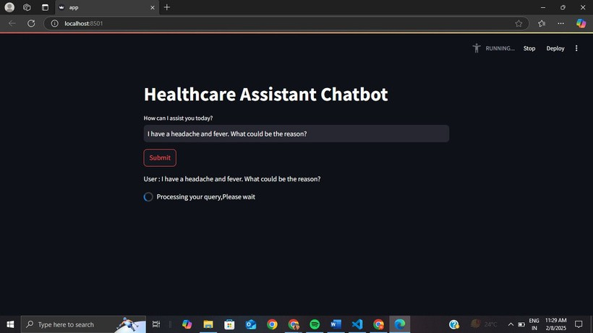

Fig8. Processing user query

p g . 1 0



* 1. **GitHub Link for Code: https://github.com/SHAHEXZER/AI-Powered-Health-Assistant-P4-Project**

# CHAPTER 5

## Discussion and Conclusion

#### Discussion

The AI-Powered Health Assistant Chatbot has demonstrated the potential of natural language processing (NLP) in enhancing accessibility to preliminary healthcare information. By leveraging Hugging Face’s DistilGPT-2, the chatbot generates contextually relevant and human-like responses to user queries. This project highlights the following insights:

Effective Use of NLP: Implementing pipeline("text-generation", model="distilgpt2") has allowed the chatbot to provide coherent and contextually appropriate responses.

User Engagement: The text-based interaction format ensures ease of use, encouraging

users to seek basic health information without hesitation.

Limitations: Despite its utility, the chatbot is limited to providing general health advice and cannot replace professional medical consultations. It also lacks real-time contextual understanding and personalization.

#### Future Work:

To further enhance the capabilities of the AI-Powered Health Assistant Chatbot, several avenues for future work can be explored:

* + - Integration with Medical Databases

Connect the chatbot with verified medical databases (e.g., Mayo Clinic, WHO) for more accurate and updated information.

* + - Enhanced NLP Models

p g . 1 1

Upgrade to advanced models like GPT-3, T5, or LLaMA for improved response generation and deeper understanding of complex medical queries.

* + - Voice-Based Interaction

Implement speech-to-text and text-to-speech functionalities for hands-free interaction, making the chatbot more accessible.

* + - Multi-Language Support

Introduce multilingual capabilities to serve a broader audience.

* + - Real-Time Doctor Consultation

Integrate telemedicine platforms for seamless transitions from chatbot interactions to professional medical consultations.

* + - Personalization and Context Awareness

Use user profiles and interaction history to provide personalized responses and follow-up advice.

* + - Mobile and IoT Integration

Develop mobile applications and integrate with IoT devices (e.g., wearable health monitors) for real-time health tracking.

#### Conclusion:

The AI-Powered Health Assistant Chatbot serves as an innovative solution for providing preliminary health-related information. Through the implementation of DistilGPT-2, the chatbot can generate informative and contextually relevant responses that help users make informed health decisions.

While it does not replace professional medical consultation, the chatbot offers a convenient first point of contact for users seeking basic medical guidance. With continuous advancements in AI and NLP, the potential for expanding this chatbot into a

comprehensive health support system is immense. Future enhancements, including

p g . 1 2

multilingual support, real-time consultations, and personalized interactions, can transform this chatbot into a more integrated and effective healthcare solution.

The journey of developing the AI-Powered Health Assistant Chatbot has not only broadened the understanding of AI’s application in healthcare but also highlighted the ethical responsibilities involved in deploying AI solutions in sensitive domains.

# REFERENCES

[1]. .Yamin, F. M., Yusof, N. M., et al. (2019). "A Review of Chatbot in Healthcare: Promises and Challenges." 2019 IEEE Conference on Open Systems (ICOS).

[2]. .Joel, J. I., Premalatha, K., et al. (2021). "Design and Implementation of a Health Care Chatbot with Deep Learning Techniques." 2021 International Conference on Communication and Signal Processing (ICCSP).

[3]. .Zhang, Y., Wang, G., et al. (2018). "An intelligent healthcare chatbot system." 2018 IEEE 8th Annual International Conference on CYBER Technology in Automation, Control, and Intelligent Systems (CYBER).

[4]. .Arpnikanondt, C., Kerdprasop, N., et al. (2020). "Development of a Rule- Based Chatbot System for Healthcare Information Retrieval." 2020 4th

International Conference on Information Science and Systems (ICISS).

p g . 1 3